Pokémon statistics



In this project you will train a computer to predict the type of Pokémon based on their statistics, like their size and fighting abilities.

Creative Commons LicenceThis project worksheet is licensed under a Creative Commons Attribution Non-Commercial Share-Alike License

http://creativecommons.org/licenses/by-nc-sa/4.0/

This is Pikachu.

Pikachu is an **electric** Pokémon.

There are lots of different types of Pokémon.

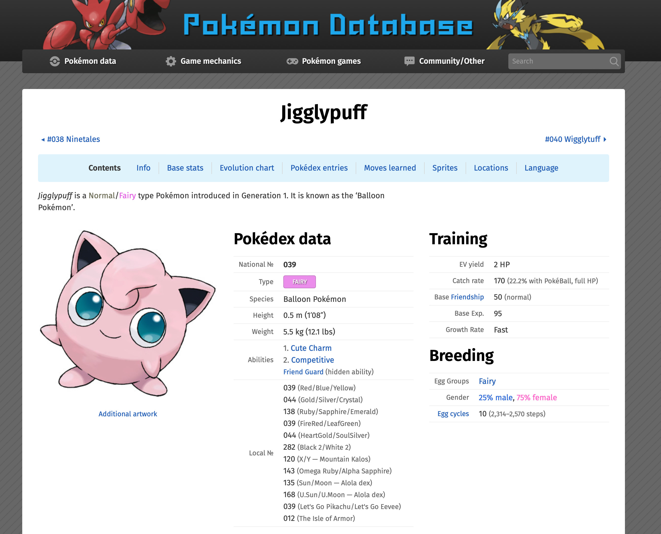

Jigglypuff is a **fairy** Pokémon.

Check the types of other Pokémon in the Pokémon database at https://pokemondb.net

The types of Pokémon are:

* Normal
* Grass
* Ground
* Rock
* Fire
* Ice
* Flying
* Ghost
* Steel
* Water
* Fighting
* Psychic
* Dragon
* Fairy
* Electric
* Poison
* Bug
* Dark

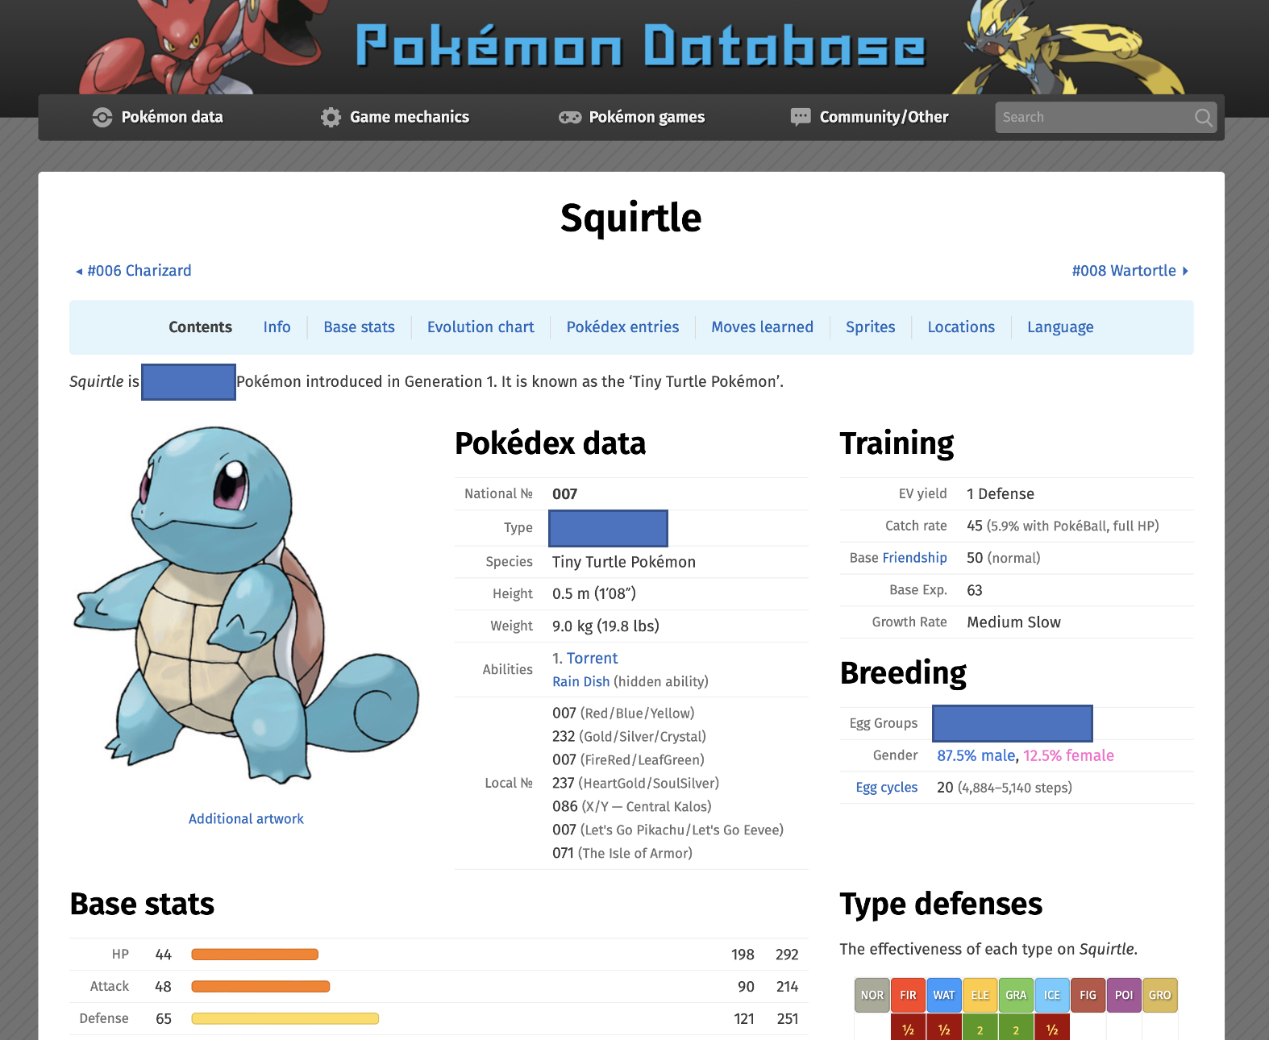

What type of Pokémon is Squirtle?

Try to guess.

What information do you think you could use to guess the type?

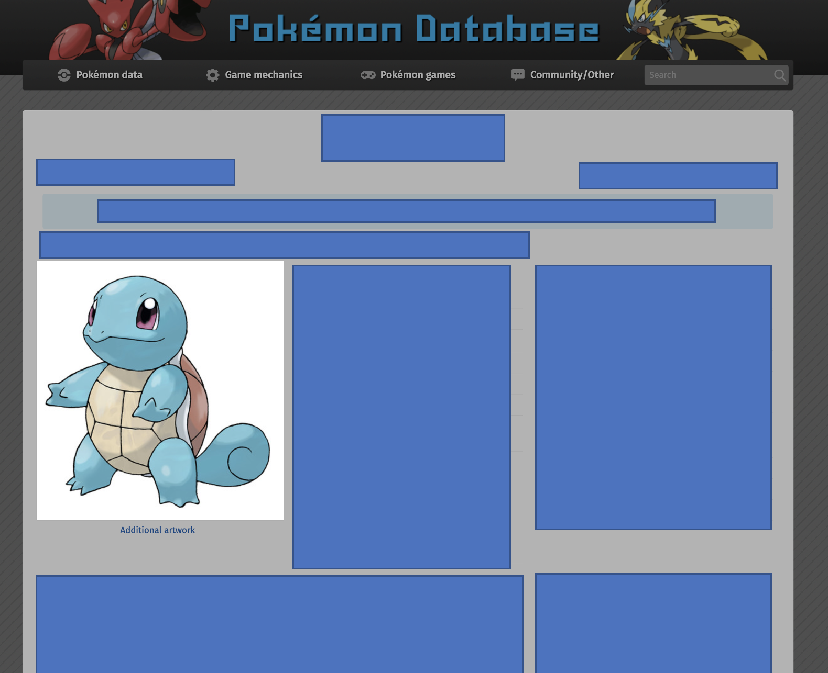Would you use the way that it **looks**?

Do you think the colours and the shapes would give you a good clue for what the type is?

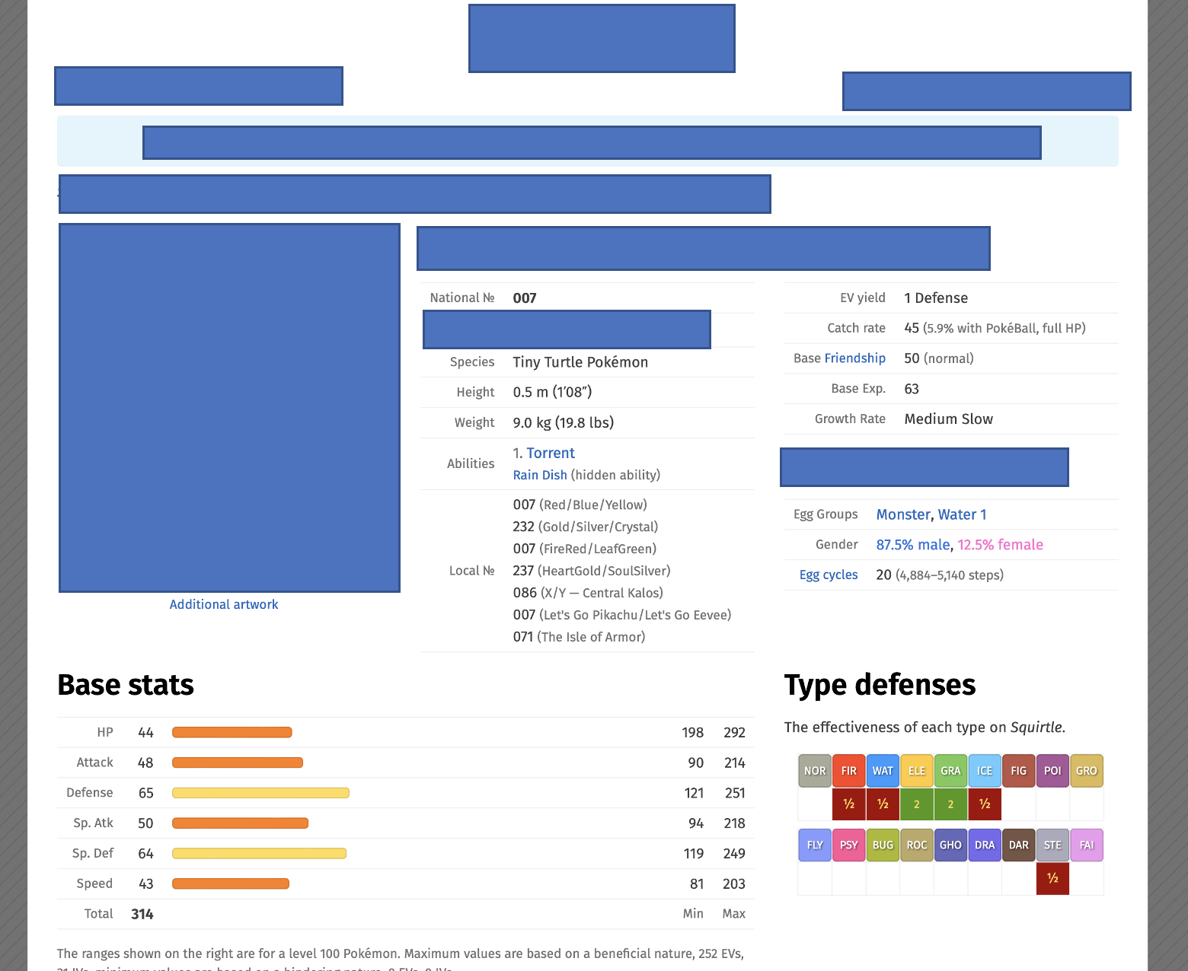

Would you use the **statistics** that describe the Pokémon’s size, abilities, and fighting style?

Do you think those numbers would give you a good clue for what the type is?

Neither is perfect.

There aren’t rules. But we can learn what they have in common and use this to make a guess.

Computers can do this. Computers can work without relying on rules, by learning what things have in common and using this to make predictions.

We call this type of computing **Machine Learning**.

In this project, you will train a computer to be able to predict the type of a Pokémon based on their statistics, by training it with the statistics for a few hundred example Pokémon.

To make things a little quicker, we won’t train the computer to recognise every type of Pokémon, we’ll just focus on six of the types as an example.

1. Go to <https://machinelearningforkids.co.uk/> in a web browser
2. Click on “**Get started**”
3. Click on “**Try it now**”
4. Click on “**Copy template**” Graphical user interface, application, website

   Description automatically generated
5. Click on **“Pokémon statistics**”   
   Graphical user interface, text, application, chat or text message

   Description automatically generated
6. Click on “**IMPORT**”, then store the project **on your computer**
7. Click on “**Pokémon statistics**”  
   **Graphical user interface, text, application, email

   Description automatically generated**
8. Click on “**Train**”  
   **Graphical user interface, text, application, website

   Description automatically generated**
9. Look through the training statistics   
   *These are the statistics for a few hundred Pokémon that you will use to train the computer with*.
10. Click on “**Back to project**”
11. Click on “**Learn & Test**”
12. Click on “**Train new machine learning model**”  
    Graphical user interface, text, application

    Description automatically generated
13. Click on “**Back to project**”
14. Click on “**Make**”
15. Click on “**Scratch 3**”  
    Graphical user interface, application

    Description automatically generated
16. Click on “**Open in Scratch 3**”  
    Graphical user interface, text, application, chat or text message

    Description automatically generated
17. Click on “**Project templates**”
18. Click on “**Pokémon statistics**”
19. Click on the “**classify**” sprite  
    Graphical user interface, application

    Description automatically generated
20. Find the “**when I receive classify**” code  
    Graphical user interface, application

    Description automatically generated
21. Update the code to use your machine learning model  
    Graphical user interface, website

    Description automatically generated
22. Click on the “**full-screen**” button  
    **Graphical user interface, application

    Description automatically generated**
23. Click on the “**Green Flag**”  
    Icon

    Description automatically generated

**What have you done so far?**

You’ve used the statistics of a random sample of a few hundred Pokémon to train a computer to be able to predict the type of a Pokémon from the numbers describing their size and abilities. You’ve set up a Scratch project that can use your machine learning model.

Next, you’ll test your model to see how good it is at guessing the type of new Pokémon.

Statistics for **six** Pokémon have been prepared for you in the Scratch project.

All six of these are Pokémon that were **not** included in the training data you used to train your machine learning model.

**Why do you think this is important?**

Drag one of them onto the red box, then click on the blue button.

The statistics for your chosen Pokémon will be displayed, along with the prediction made by your machine learning model.

(The picture of the Pokémon is not used by the machine learning model - it’s just included in the project to make it look better!)

Pokémon images used in this activity came from

https://www.kaggle.com/vishalsubbiah/pokemon-images-and-types

Pokémon data used in this activity came from

https://www.kaggle.com/abcsds/pokemon

Other screenshots used in this activity came from

https://pokemondb.net

©2022 Pokémon. ©1995 - 2022 Nintendo/Creatures Inc./GAME FREAK inc. TM, ®Nintendo

**Ideas and Extensions**

Now that you’ve finished, why not give one of these ideas a try?

Or come up with one of your own?

**Design your own Pokémon!**

Try inventing your own Pokémon. A sprite called “your-pokemon” is included in the Scratch project ready for you to fill in.

You can draw a Pokémon in Scratch using the drawing tools for a new sprite.

Or you can draw it with pen and paper, and then use the camera tool to create a new costume in Scratch from a webcam photo of your drawing.

Then you can fill in the statistics for your Pokémon.

What type does your machine learning model think it is?